**EE-107: Communication Systems Final Project Midpoint Report**

Alexander Christenson and Stamatios Aleiferis

Tufts University Department of Electrical and Computer Engineering

Professor Mai Vu – Fall 2017

**Section 2.4 Modulation**

Question 1) Plot the two pulse shaping functions and the frequency responses of both pulses:

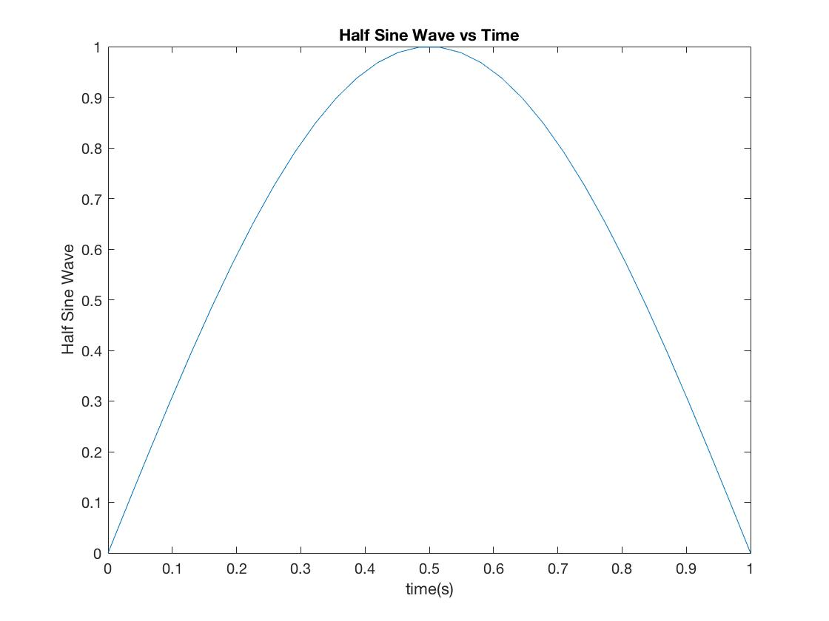

Figure . Plot of Half Sine Wave pulse, T = 1

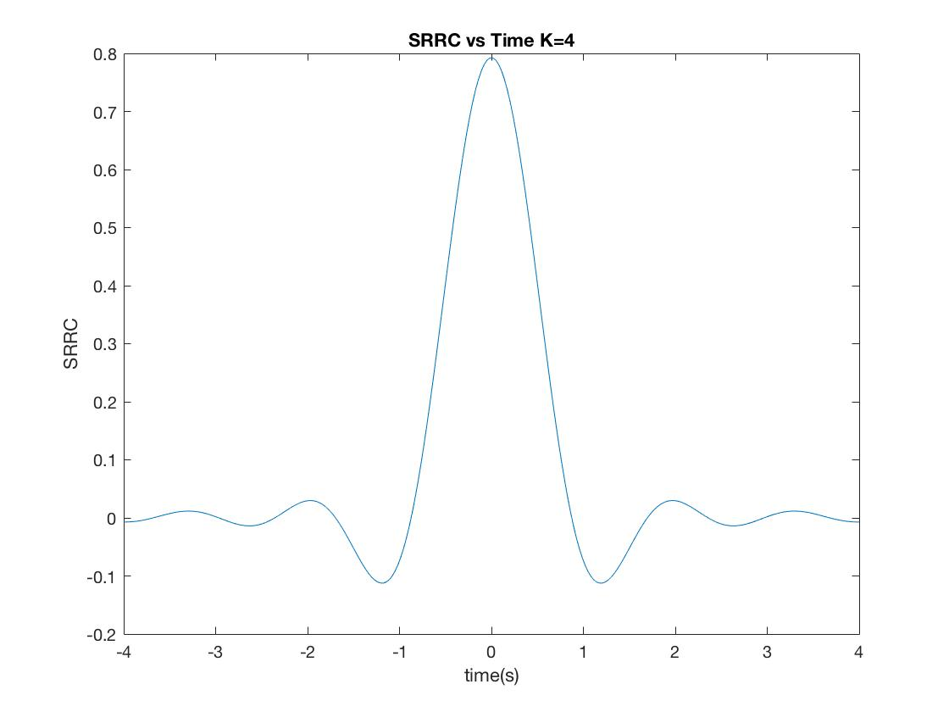

Figure . Square Root Raised Cosine pulse: Bit duration, T = 1; Truncation Constant, K = 4; Roll-off factor alpha = 0.5

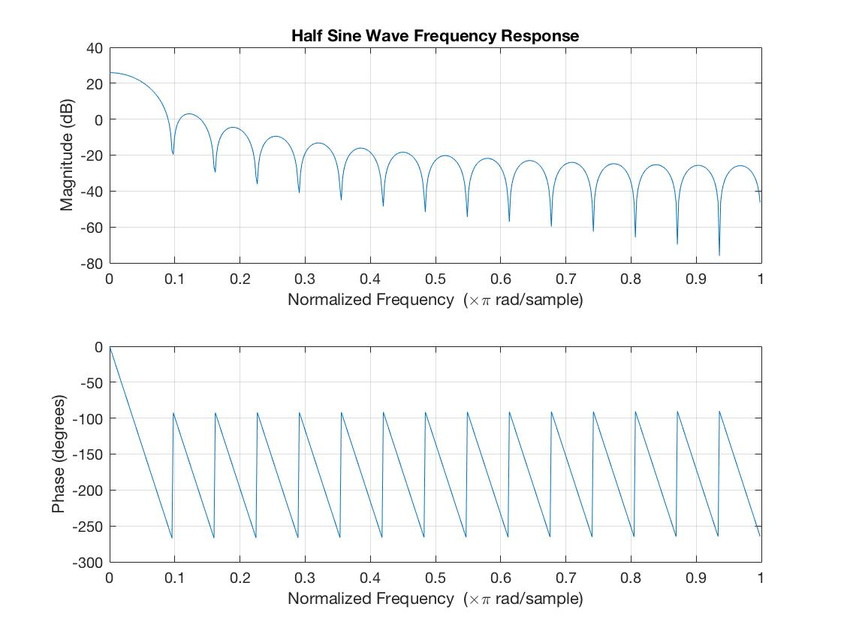

Figure . Half sine wave pulse frequency response

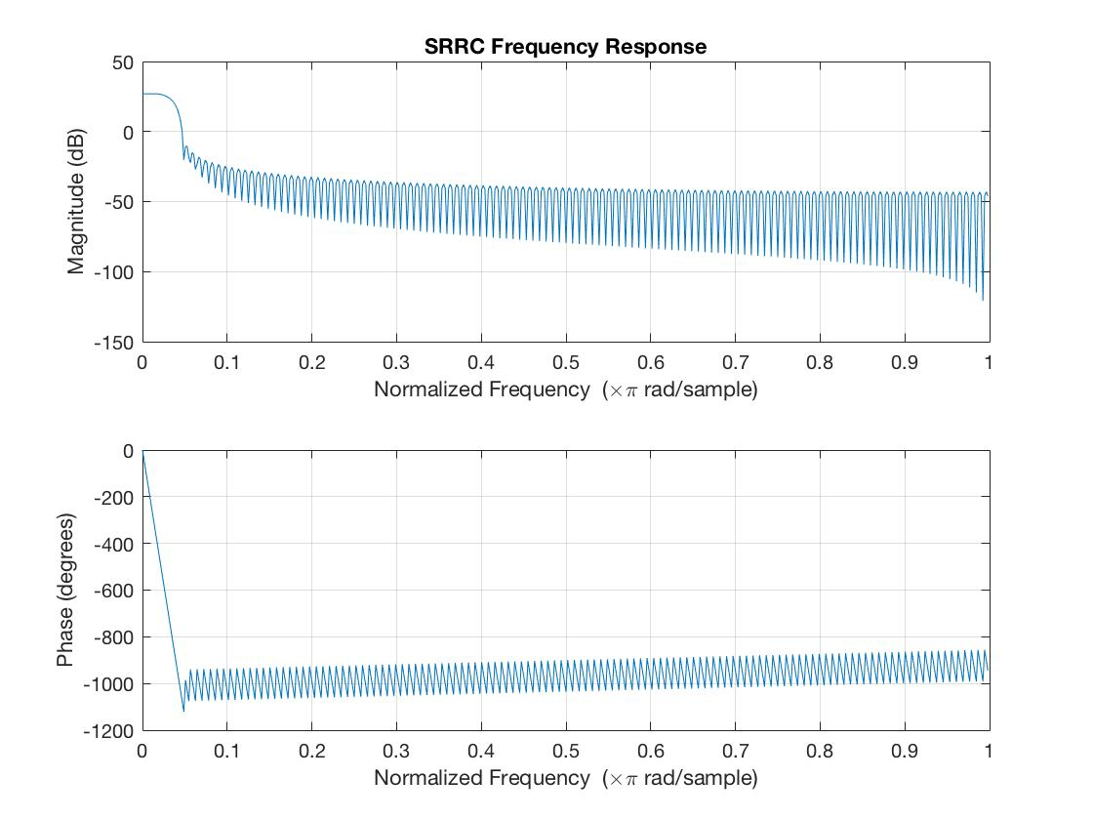

Figure . SRRC frequency response

Which pulse uses more bandwidth?

* From the frequency response diagrams in figures three and four it is very clear the that half sine wave uses more bandwidth because of the size of the main lobes.
* This means that when using the half sine wave in a transmission system is going to be less bandwidth efficient than the square root raised cosine. As you can see from the graph, the Square Root Raised Cosine pulse will also highly attenuate high frequency signals

If you increase the length of the truncated SRRC pulse, what do you expect to see in the frequency response?

* As you increase the length of the truncated SRRC pulse the frequency response becomes more like a perfect low pass filter. There are some oscillations that happen in the higher frequency parts and these oscillations become faster as K increases.
* If you make alpha a number closer to zero, then the main lobe of the impulse response of the SRRC becomes wider and as you increase alpha the main lobe becomes even skinnier. The frequency response is sharper as alpha gets closer to zero and becomes smoother as alpha goes to one.

Question 2) Plot the spectrum of the of the modulated signal and compare the pulse spectrum for each pulse. Notice how the HS modulated signal has a super negative spike at w = 0, but has a much more gradual slope than the SRRC response. The SRRC response also has periodic spikes that shoot down very low.

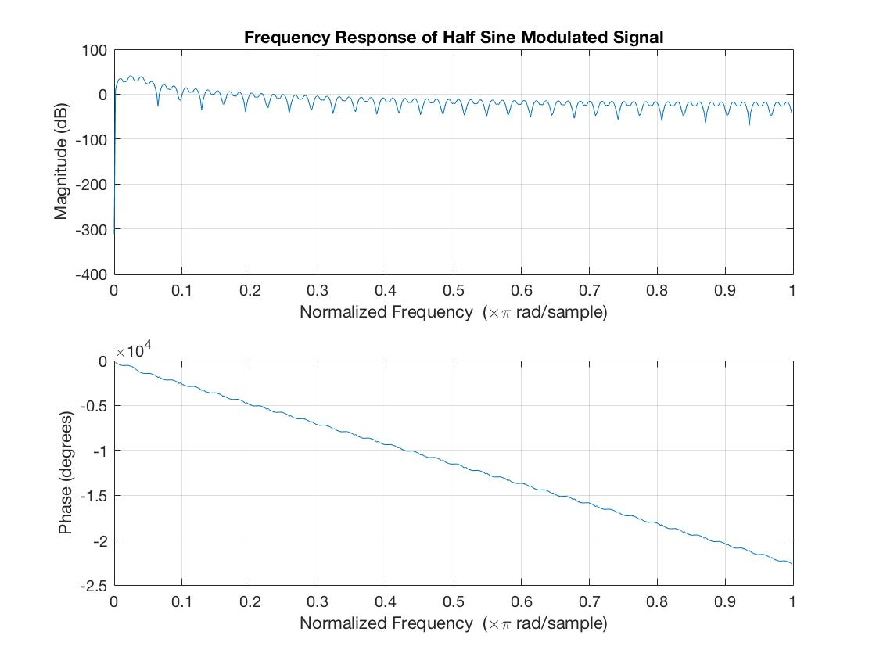

Figure . Half sine modulated signal frequency response

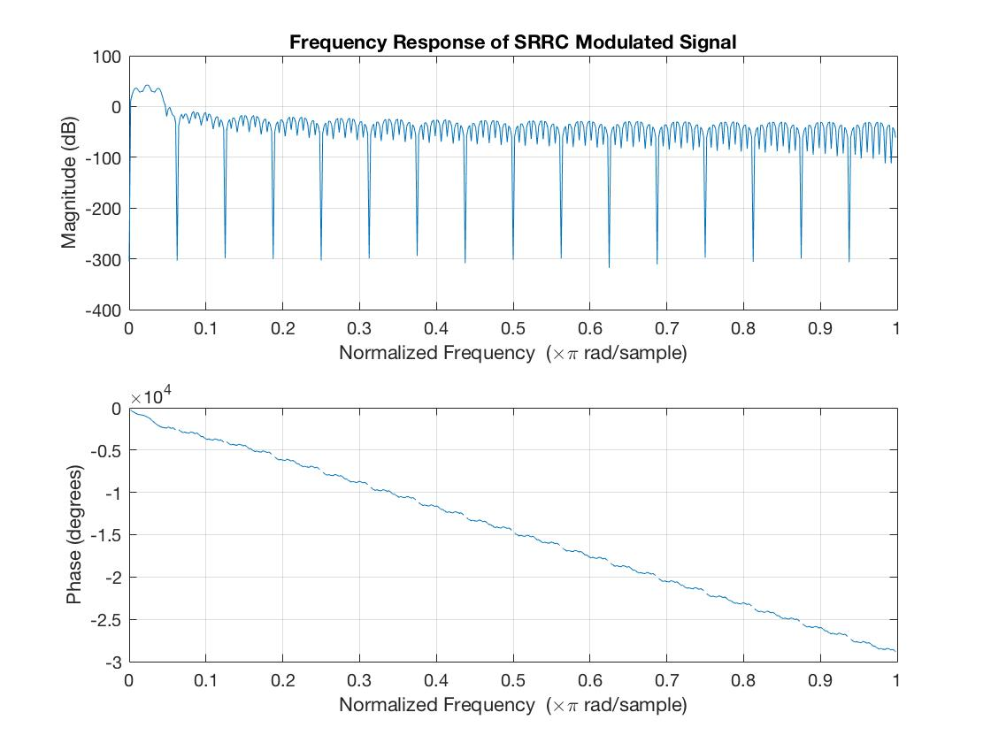

Figure . SRRC modulated signal frequency response

Question 3) Plot a stream of ten random bits modulated by each signal: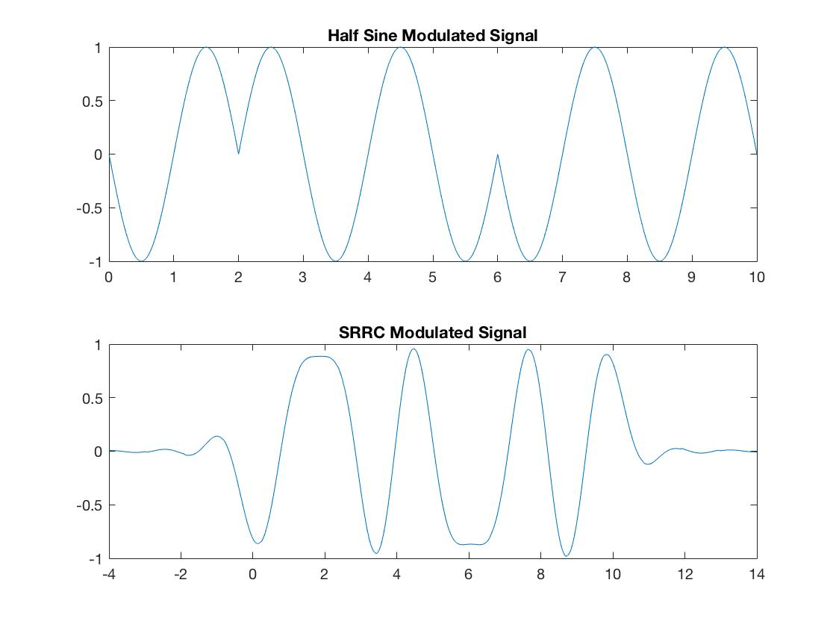

Figure . HS and SRRC Modulated 10 Bit Stream, time in seconds on x axis, signal amplitude on y axis

There’s a lot of interference from the overlap in the SRRC modulation and you can very clearly see the bits from the half sine modulation, which has no overlap.

Question 4) Plot the transmit eye diagram for both pulses.

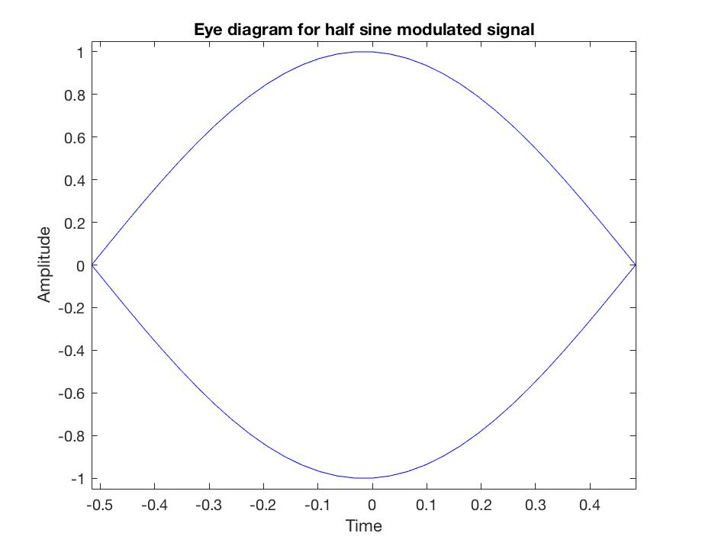

Figure . Transmit Eye diagram for half sine pulse

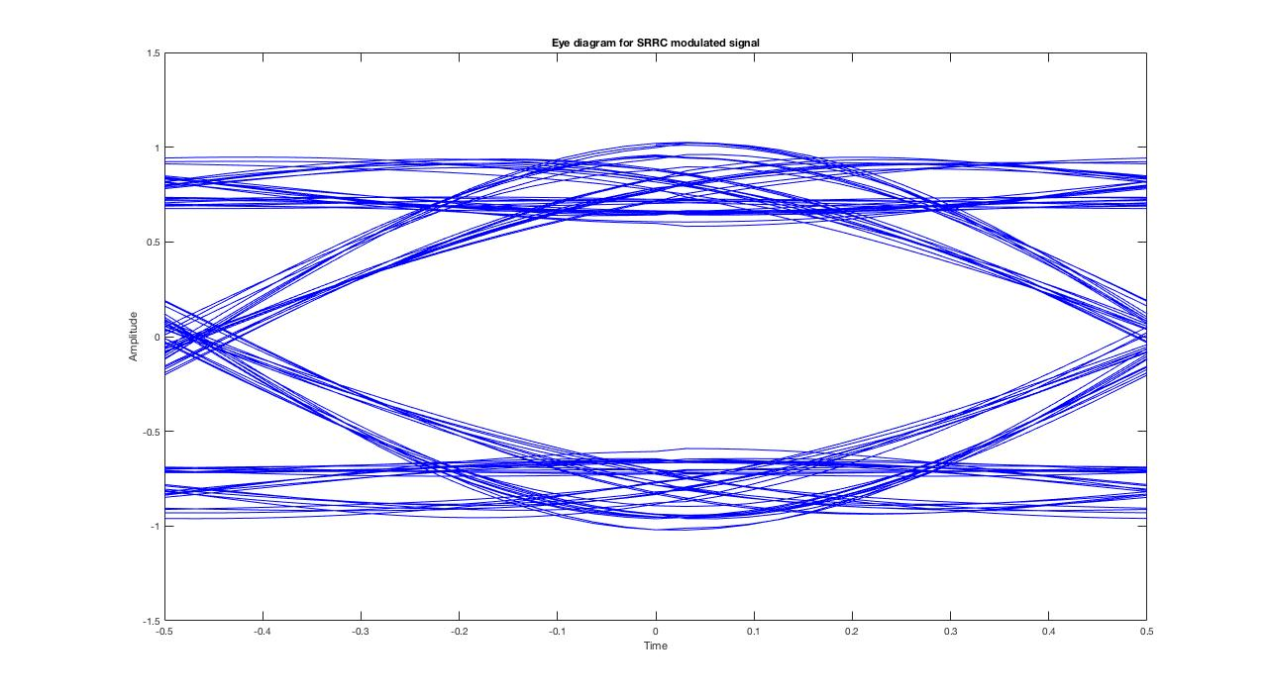

Figure . Transmit eye diagram for SRRC pulse

Do you observe the eye opening?

* Yes, the eye opening is very clear for both the half sine and SRRC modulated waveforms. The SRRC looks better and has a more well-defined eye when more bits are used, but both you can clearly see the opening. The SRRC is similar in shape to the HS but the half sine does not have any signal components that are kind of horizontal at the max amplitude like the SRRC does.

Section 2.5 Channel

Question 5): Plot the frequency response and impulse response of the channel

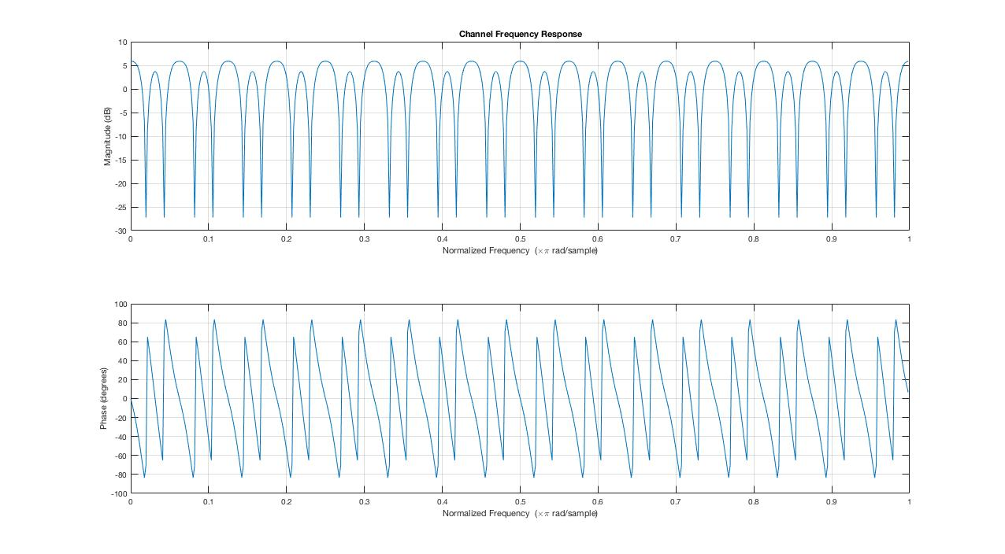

Figure . Channel frequency response

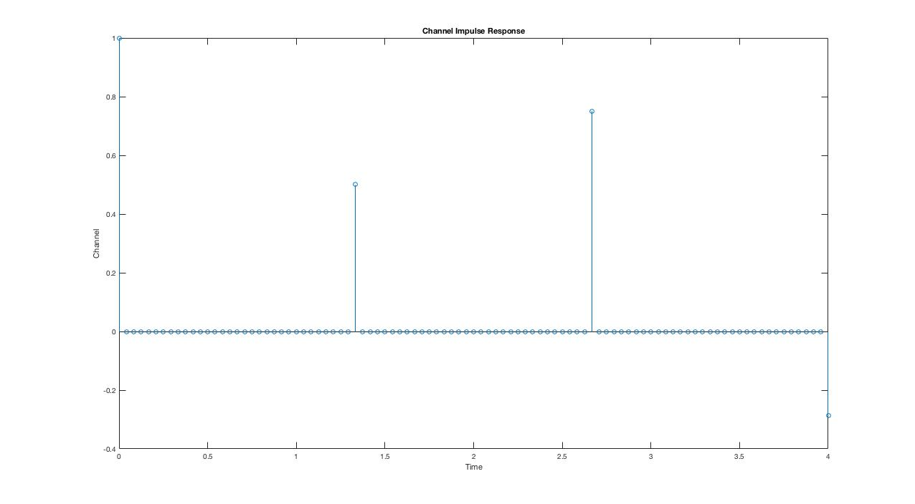

Figure . Channel impulse response

Question 6: Plot the eye diagram of the channel output for each pulse shaping function

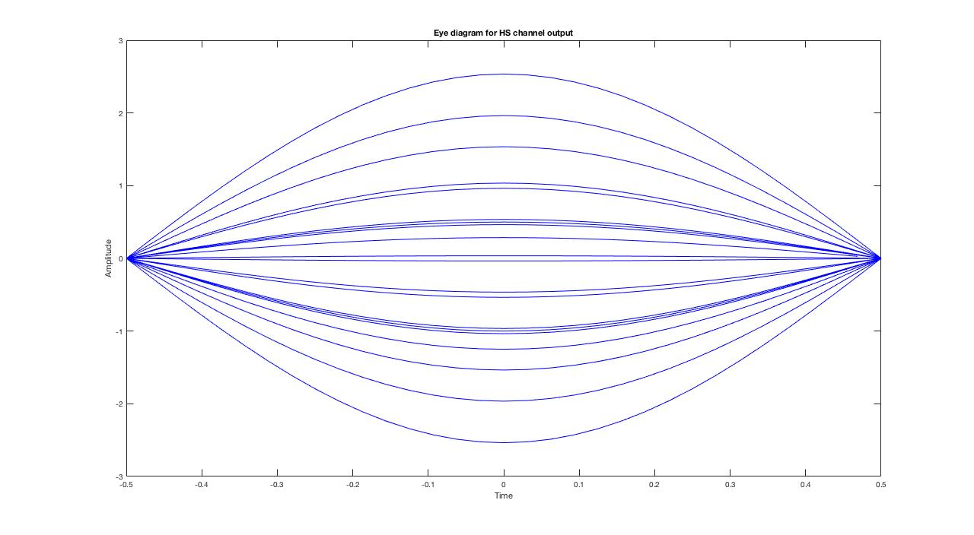

Figure Eye diagram of the channel output for the half sine modulated signal

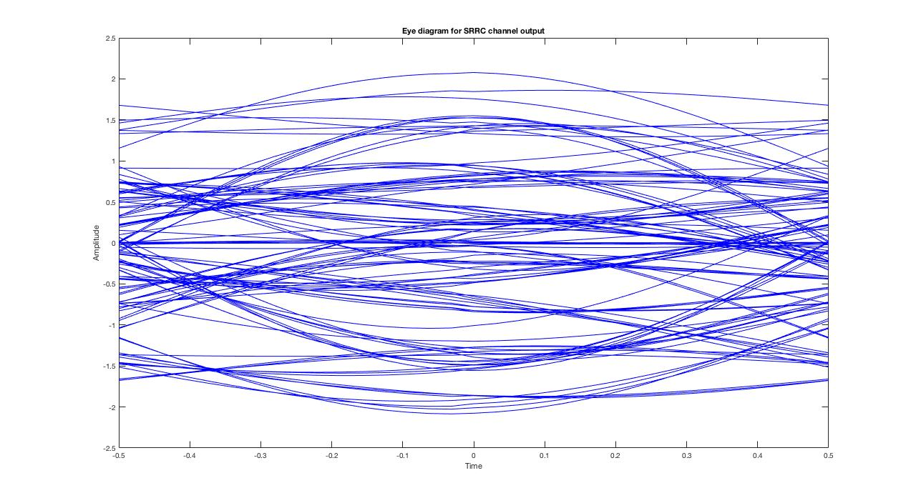

Figure Eye diagram of the channel output for the SRRC modulated signal

For both plots, the eye opening is smaller, due to Inter Symbol Interference. In the case of half sine wave the eye just looks more closed than without the channel introducing ISI. The SRRC eye diagram looks a lot messier and doesn’t hold up to the channel delays as well as the HS does.

Section 2.6 Noise

Question 7: Plot the two eye diagrams of the channel output with noise added.

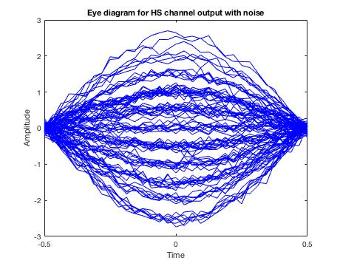

Figure Channel output for the half sine modulated signal with noise added

Noise power σ2 = 0.01.

This level of noise power causes the eye to look even more closed in the half sine pulse. The SRRC looks very messy and becomes almost unreadable.

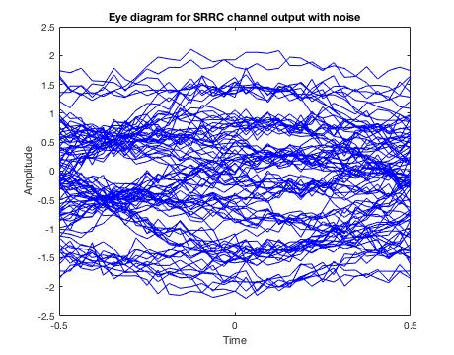

Figure Channel output for the SRRC modulated signal with noise added

2.7 Matched Filter

Question 8: Plot the impulse response and frequency response of the matched filter for each pulse shaping function.

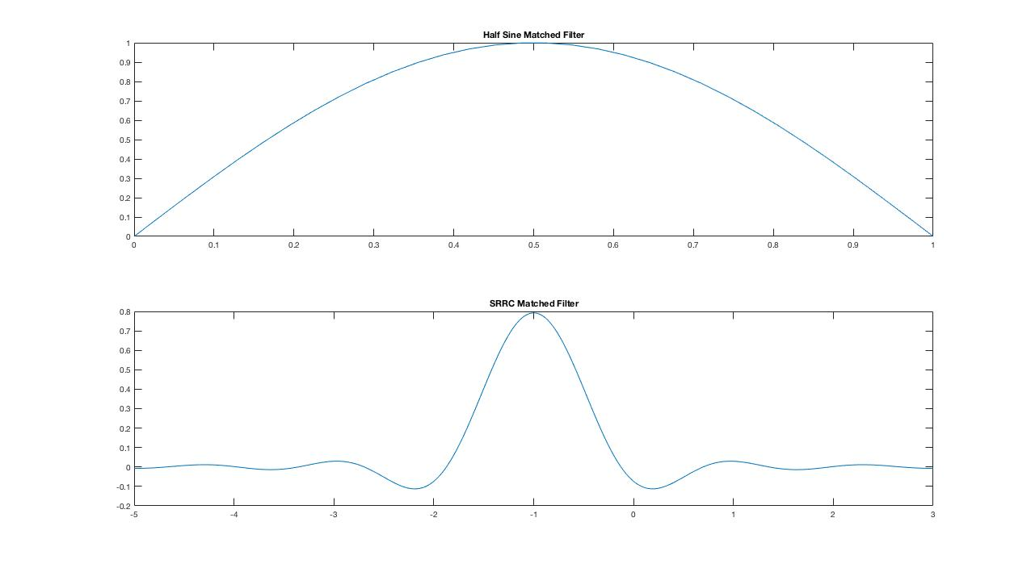

Figure Matched filter impulse response. Top: Half sine Bottom: SRRC, K=4, T=1, α=0.5

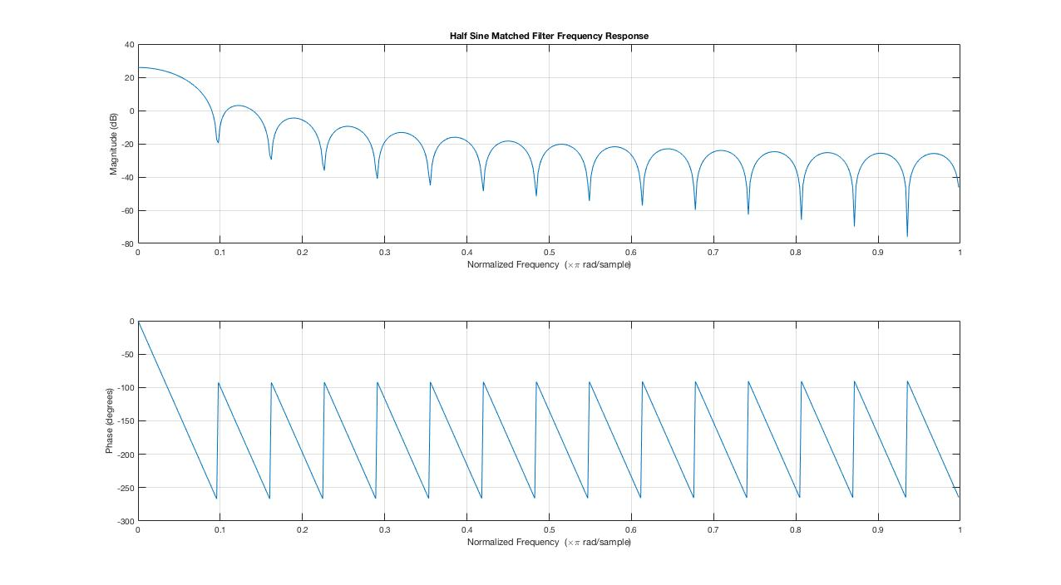

Figure Frequency response of half sine matched filter

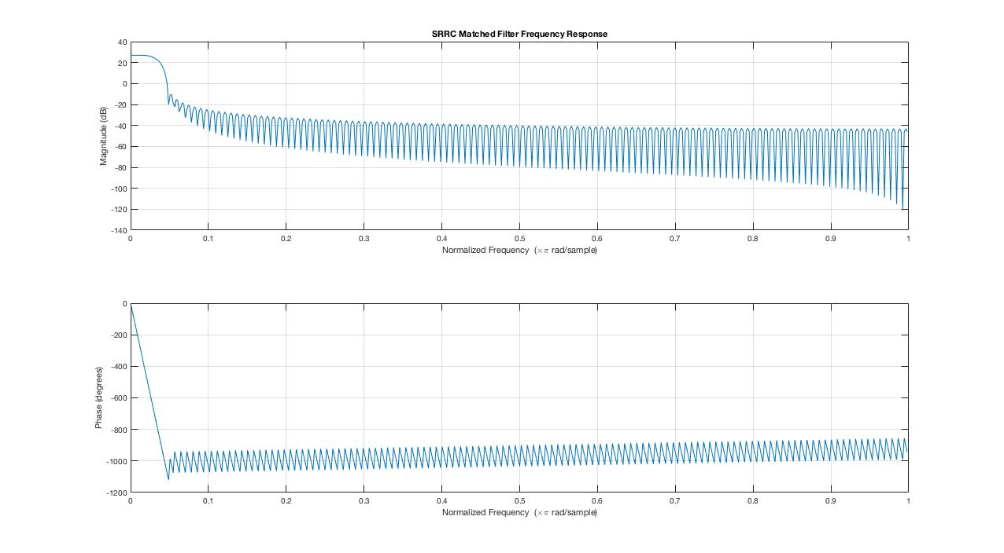

Figure Frequency response of SRRC matched filter

Question 9: Plot the eye diagram for each pulse shape at the output of the matched filter

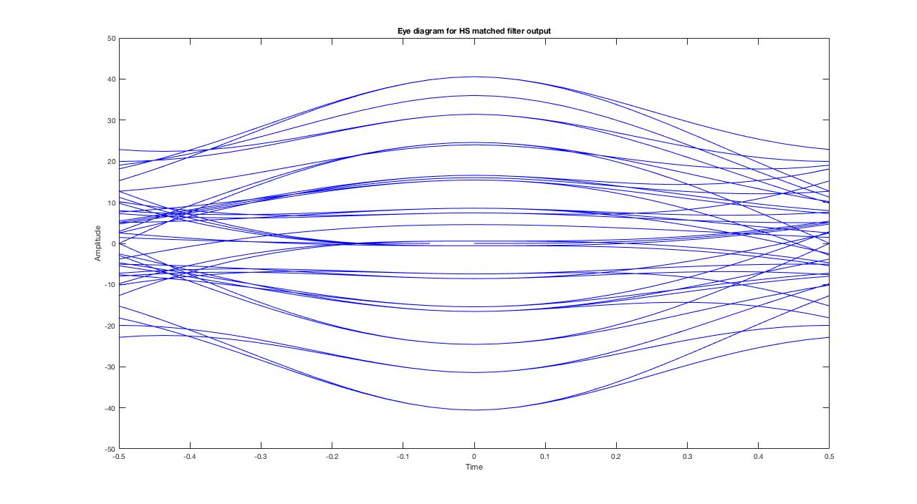

Figure Eye diagram for the pulse shape at the output of the half sine matched filter

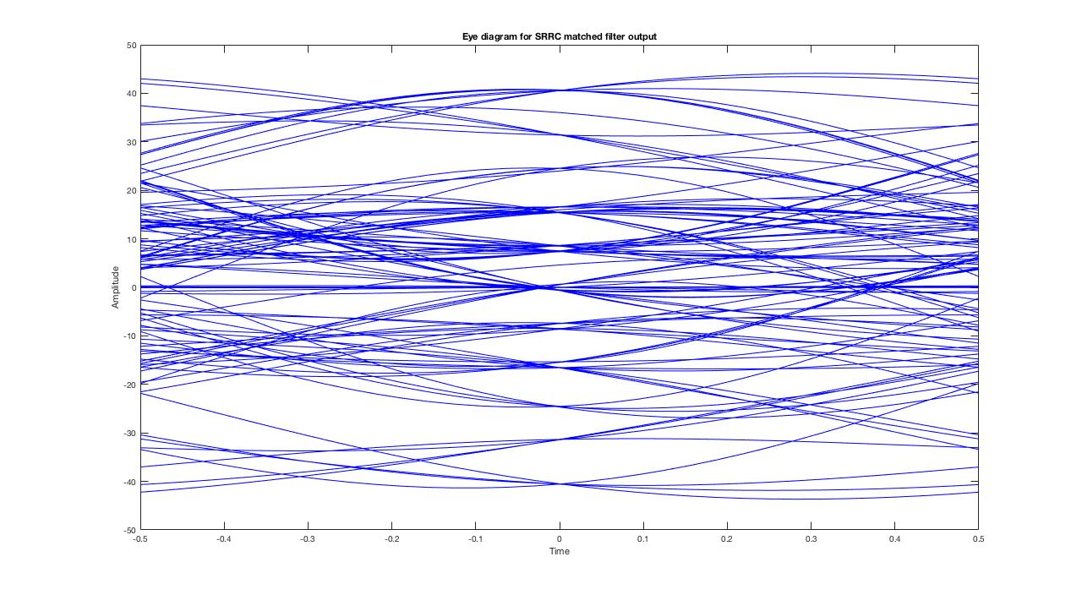

Figure Eye diagram for the pulse shape at the output of the SRRC matched filter

According to the eye diagrams above, the best sampling point will be at intervals of the bit duration kT, which corresponds to t = 0 on the eye diagram. At that time, it can be seen that the different pulses meet and form distinct levels, the value of which can be used to decide on the bit value that was originally transmitted.